6115-MAHENDRA INSTITUTE OF ENGINEERING AND TECHNOLOGY

*NOISE POLLUTION MONITORING*

TEAM: PROJ_223288_TEAM_1

Team id: 570

Year: III

|  |
| --- |
| Team Members Name  YASVANTHRAJ.S  VIGNESHWARAN.M  VIGNESH.J  TAMIL SELVAN.A.D  SURESH.D  SURENDIRA BABU.D  Mentor Name  M.SANTHANARAJ |

INSTALLATION

There are several ways to install noise pollution monitoring systems. The installation process depends on the type of system you are using and the location where it will be installed. Here are some general steps that can be followed:

**Choose the right location**: The location of the monitoring system is crucial. It should be installed in an area where noise pollution is a concern, such as near a busy road or construction site.

**Select the right equipment**: There are many different types of equipment available for noise pollution monitoring. Choose the one that best suits your needs and budget.

**Install the equipment**: Once you have selected the equipment, follow the manufacturer’s instructions to install it correctly.

**Calibrate the equipment**: Calibration is essential to ensure that the equipment is measuring noise levels accurately. Follow the manufacturer’s instructions to calibrate the equipment.

[**Connect to IoT platform**: If you are using an IoT-based noise pollution monitoring system, connect it to an IoT platform such as Blynk or Thingspeak](https://cpcb.nic.in/guidelines/) .

**Monitor and analyze data**: Once the system is installed and connected, you can start monitoring and analyzing data. This will help you identify areas where noise pollution is high and take appropriate measures to reduce it.

Please note that these are general steps, and the installation process may vary depending on the type of system you are using.

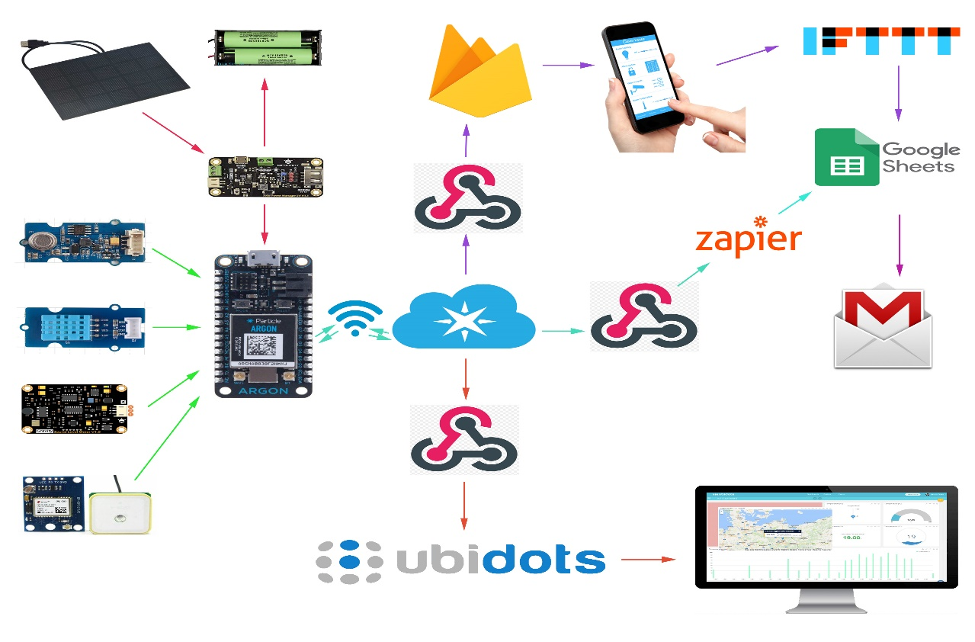

PLANNING

[There are several strategies and implications of noise pollution monitoring, modelling, and mitigation in urban cities](https://link.springer.com/referenceworkentry/10.1007/978-981-19-1550-5_86-1) . [The present chapter provides an exhaustive review on the noise monitoring studies, comparison of the prediction models including physical propagation model, and applications of the artificial intelligence techniques, noise mapping, and noise pollution monitoring in mining sector carried out by various researchers](https://link.springer.com/referenceworkentry/10.1007/978-981-19-1550-5_86-1) .

Noise prediction models play a vital role in city planning for control and abatement of noise pollution. [Therefore, a lot of mathematical/hybrid/artificial intelligence models had been developed in past years introducing sound propagation and sound specific emission empirical formulation](https://link.springer.com/referenceworkentry/10.1007/978-981-19-1550-5_86-1) .

In terms of planning for installation of noise pollution monitoring systems, there are several steps that can be followed. [These include choosing the right location, selecting the right equipment, installing the equipment, calibrating the equipment, connecting to an IoT platform if applicable, and monitoring and analyzing data](https://www.gov.uk/government/collections/noise-management) . Please note that these are general steps, and the installation process may vary depending on the type of system you are using.

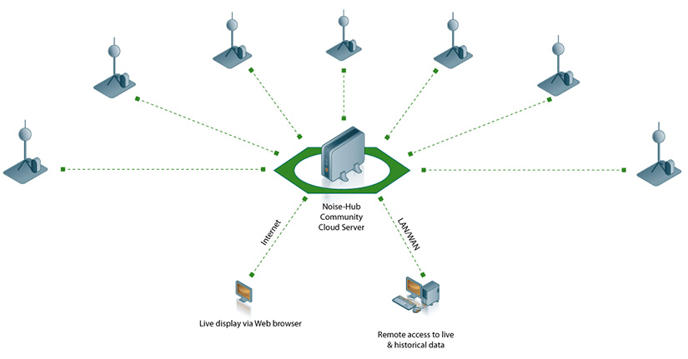

EXECUTION

The main objective of this work is the development of a Vehicle Ad Hoc NETwork (VANET) to collect data from GPS equipped mobile phones used as noise detectors. In this system, sensor nodes perioadically transmit acoustic noise levels to neighboring cars, data packets being shared and temporary stored by participating VANET nodes and ultimately forwarded to a collector node connected to the Internet, providing public real-time data. A routing technique called MP-OLSR that takes into account the spatially separation between the multiple paths is used, for better transmission reliability and congestion avoidance as well as for control message overhead minimization.

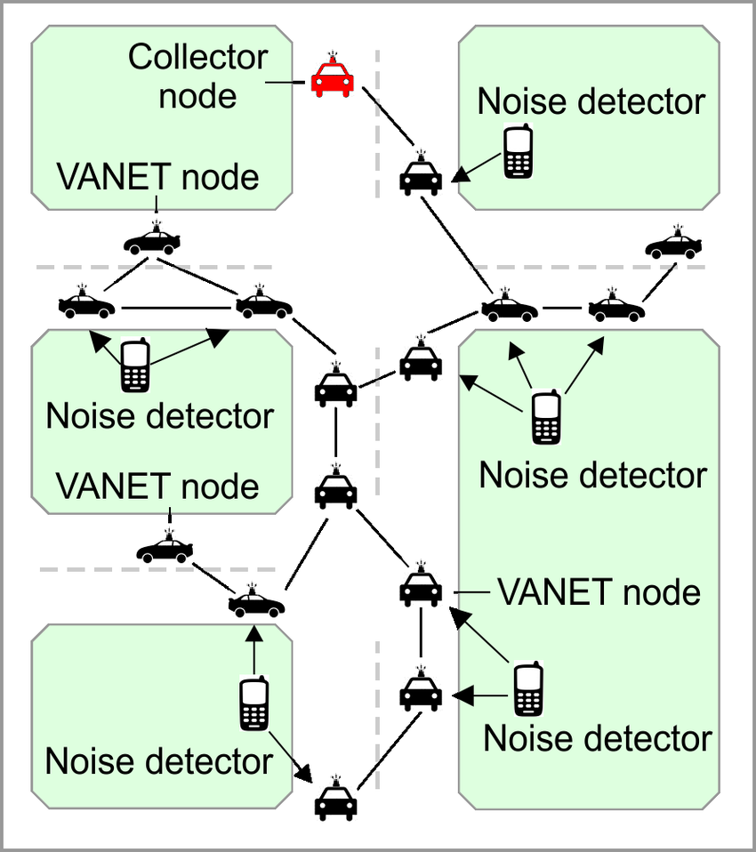

Controlling

There are several ways to control noise pollution. [The Central Pollution Control Board (CPCB) in India has implemented the Noise Pollution (Regulation and Control) Rules, 2000 to regulate and control noise-producing and generating sources](https://cpcb.nic.in/noise-pollution-rules/) . [The authority is responsible for enforcing noise pollution control measures and ensuring compliance with ambient air quality standards in respect of noise](https://cpcb.nic.in/noise-pollution-rules/) . [The use of loudspeakers and public address systems is restricted under these rules](https://cpcb.nic.in/noise-pollution-rules/) .

In addition to regulatory measures, there are several other ways to control noise pollution. [These include designing quieter machines, using acoustic enclosures and vibration isolators, increasing the distance of transmission, and using noise-canceling headphones or earplugs](https://prepp.in/news/e-492-measures-to-control-noise-pollution-environment-notes) .

The book Environmental Noise Control: The Indian Perspective in an International Context provides an extensive review of recent studies, including references, and describes the latest noise monitoring structures. [It also addresses heretofore under-emphasized topics, including but not limited to acoustic metrology, Multi Attribute Decision Making (MADM) techniques, and sound insulation utilizing passive control strategies](https://link.springer.com/book/10.1007/978-3-030-87828-3) .

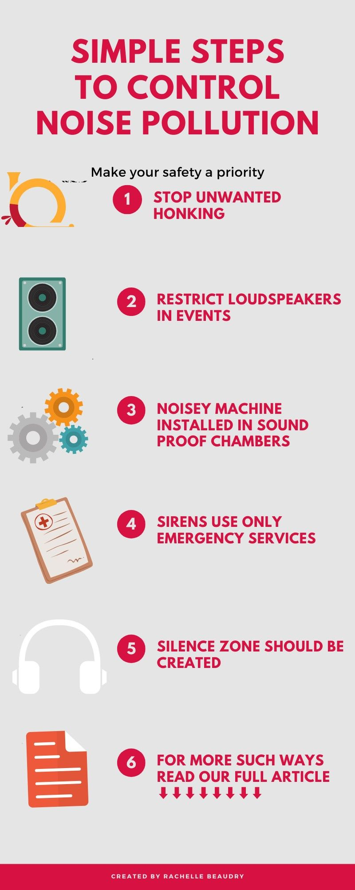

**Monitoring Construction Site Noise Limits**

The noise conditions set for the site were complex, with different noise levels being permitted at different times of day and night and with separate noise conditions for Saturdays, Sundays and Bank Holidays.

The client required that if any of the noise limits for the site were breached, or if the site was getting near its permitted cumulative noise levels for the day, alerts would be sent to a number of different parties.

|  |
| --- |
| THANK YOU |